**Launch Desktop Apps StreamerBot Extension**

**Created by Vengey**

**[** [**https://twitter.com/ItsVengey**](https://twitter.com/ItsVengey) **|** [**https://www.twitch.tv/itsvengey**](https://www.twitch.tv/itsvengey) **|** [**https://vengey.carrd.co/**](https://vengey.carrd.co/) **]**

**How to Import into StreamerBot…**

**STEP 1: *Copy this LONG string***



**STEP 2**: ***Click Import in Streamerbot***

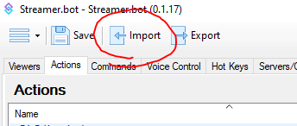

**STEP 3**: ***Paste the code into “Import String”, an action will show up, then hit “Import”***

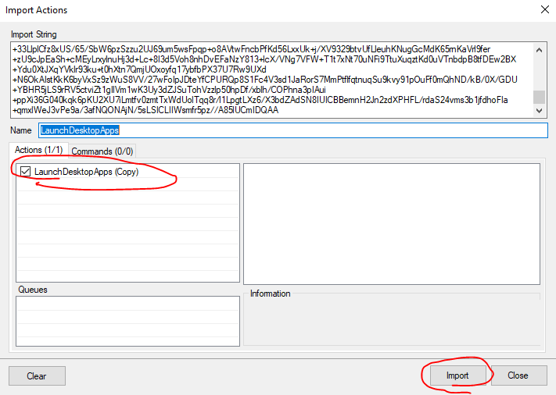

**STEP 4**: ***Go to your Actions tab; look for an action called “LaunchDesktopApps” and double click the sub-action labeled “Execute Code”***

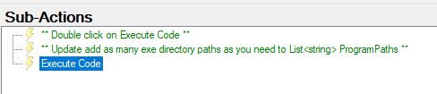

Replace each instance of a string delimited by @””, with the absolute directory of where your .exe file is located

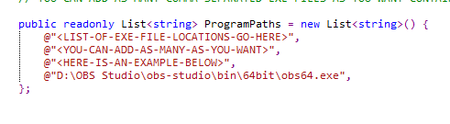

For example, this is what mine looks like

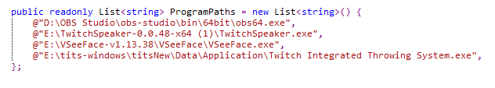

You can add as many as you’d like, or delete ones you don’t need!

This code will ONLY open apps you list and ONLY open ones that are not already opened!

**STEP 5:** ***Wire this action up!***

I personally recommend wiring it up via hotkey, or streamdeck button!